level 3

code:

using System;

using System.Collections.Generic;

using System.Linq;

using System.Net;

using System.Windows;

using System.Windows.Controls;

using System.Windows.Documents;

using System.Windows.Input;

using System.Windows.Media;

using System.Windows.Media.Animation;

using System.Windows.Shapes;

using Microsoft.Phone.Controls;

namespace MD

{

public partial class Page16 : PhoneApplicationPage

{

public Page16()

{

InitializeComponent();

System.Threading.Thread startupThread =

new System.Threading.Thread(new System.Threading.ThreadStart(timeDec));

startupThread.Start();

}

Boolean flag = true;

Boolean flag3 = true;

void timeDec()

{

int k = 20, j = 1, m = 0;

for (int i = 0; i < 121; i++)

{

System.Threading.Thread.Sleep(1000);

this.Dispatcher.BeginInvoke(() =>

{

if (flag)

{

if (flag3)

{

string s1;

s1 = textBlock7.Text;

int num = int.Parse(s1);

num--;

s1 = num.ToString();

textBlock7.Text = s1;

//int q = int.Parse(s1);

if (i == 120)

{

flag = false;

}

}

else

{

}

}

else

{

// NavigationService.Navigate(new Uri("/Page36.xaml", UriKind.Relative));

}

});

}

// doStuff3();

}

private void image1_ImageFailed(object sender, ExceptionRoutedEventArgs e)

{

}

private void button1_Click(object sender, RoutedEventArgs e)

{

NavigationService.Navigate(new Uri("/Page17.xaml", UriKind.Relative));

}

int i = 3, m = 2;

Boolean flag1 = true;

Boolean flag2 = true;

private void button3_Click(object sender, RoutedEventArgs e)

{

string s1;

s1 = textBox1.Text;

if (s1 == "moral support")

{

flag3 = false;

button1.Visibility = Visibility;

textBlock10.Text = "E";

textBlock11.Text = "C";

textBlock2.Visibility = Visibility.Collapsed;

textBlock3.Visibility = Visibility.Collapsed;

textBlock5.Text = "You got it Right. 2 of 6 letters are unlocked...Press Continue";

}

else

{

textBlock5.Text = "Sorry You are wrong !!!";

if (flag1 == false)

{

}

textBox1.Text = "";

if (m != 0)

{

if (m == 2)

{

textBlock5.Text = "Sorry You are wrong !!!";

textBlock3.Text = "2"; m--;

}

else if (m == 1)

{

textBlock5.Text = "Sorry You are wrong again !!!";

textBlock3.Text = "1"; m--;

}

}

else

{

if (flag2)

{

image3.Visibility = Visibility.Collapsed;

textBlock5.Text = "You lost a life !!! ";

textBlock3.Text = "3";

m = 2;

flag2 = false;

}

else

{

NavigationService.Navigate(new Uri("/Page35.xaml", UriKind.Relative));

}

}

}

}

}

}

using System;

using System.Collections.Generic;

using System.Linq;

using System.Net;

using System.Windows;

using System.Windows.Controls;

using System.Windows.Documents;

using System.Windows.Input;

using System.Windows.Media;

using System.Windows.Media.Animation;

using System.Windows.Shapes;

using Microsoft.Phone.Controls;

namespace MD

{

public partial class Page17 : PhoneApplicationPage

{

public Page17()

{

InitializeComponent();

System.Threading.Thread startupThread =

new System.Threading.Thread(new System.Threading.ThreadStart(timeDec));

startupThread.Start();

}

Boolean flag1 = true;

Boolean flag3 = true;

void timeDec()

{

int k = 20, j = 1, m = 0;

for (int i1 = 0; i1 < 121; i1++)

{

System.Threading.Thread.Sleep(1000);

this.Dispatcher.BeginInvoke(() =>

{

if (flag1)

{

if (flag3)

{

string s1;

s1 = textBlock8.Text;

int num = int.Parse(s1);

num--;

s1 = num.ToString();

textBlock8.Text = s1;

//int q = int.Parse(s1);

if (i1 == 120)

{

flag1 = false;

}

}

else

{

}

}

else

{

//NavigationService.Navigate(new Uri("/Page36.xaml", UriKind.Relative));

}

});

}

// doStuff3();

}

int m = 2, i = 3;

Boolean flag = true;

Boolean flag2 = true;

private void button3_Click(object sender, RoutedEventArgs e)

{

if (flag)

{

string s1;

s1 = textBox1.Text;

if (s1 == "sponge")

{

flag3 = false;

button3.Content = "continue"; flag = false;

textBlock6.Text = "You got it Right. 4 of 6 letters are unlocked...Press Continue";

textBlock13.Text = "P";

textBlock14.Text = "A";

}

else

{

textBlock6.Text = "Sorry You are wrong !!!";

textBox1.Text = "";

if (m != 0)

{

if (m == 2)

{

textBlock6.Text = "Sorry You are wrong !!!";

textBlock5.Text = "2"; m--;

}

else if (m == 1)

{

textBlock6.Text = "Sorry You are wrong again !!!";

textBlock5.Text = "1"; m--;

}

}

else

{

if (flag2)

{

image3.Visibility = Visibility.Collapsed;

textBlock6.Text = "You lost a life !!! ";

textBlock5.Text = "3";

m = 2;

flag2 = false;

}

else

{

NavigationService.Navigate(new Uri("/Page35.xaml", UriKind.Relative));

}

}

}

}

else

{

NavigationService.Navigate(new Uri("/Page18.xaml", UriKind.Relative));

}

}

private void image1_ImageFailed(object sender, ExceptionRoutedEventArgs e)

{

}

}

}

using System;

using System.Collections.Generic;

using System.Linq;

using System.Net;

using System.Windows;

using System.Windows.Controls;

using System.Windows.Documents;

using System.Windows.Input;

using System.Windows.Media;

using System.Windows.Media.Animation;

using System.Windows.Shapes;

using Microsoft.Phone.Controls;

namespace MD

{

public partial class Page18 : PhoneApplicationPage

{

public Page18()

{

InitializeComponent();

System.Threading.Thread startupThread =

new System.Threading.Thread(new System.Threading.ThreadStart(timeDec));

startupThread.Start();

}

Boolean flag1 = true;

Boolean flag3 = true;

void timeDec()

{

int k = 20, j = 1, m = 0;

for (int i2 = 0; i2 < 121; i2++)

{

System.Threading.Thread.Sleep(1000);

this.Dispatcher.BeginInvoke(() =>

{

if (flag1)

{

if (flag3)

{

string s1;

s1 = textBlock8.Text;

int num = int.Parse(s1);

num--;

s1 = num.ToString();

textBlock8.Text = s1;

//int q = int.Parse(s1);

if (i2 == 120)

{

flag1 = false;

}

}

else

{

}

}

else

{

//NavigationService.Navigate(new Uri("/Page36.xaml", UriKind.Relative));

}

});

}

// doStuff3();

}

int m = 2, i = 3;

Boolean flag = true;

Boolean flag2 = true;

private void button3_Click(object sender, RoutedEventArgs e)

{

if (flag)

{

string s1;

s1 = textBox1.Text;

if (s1 == "russia")

{

flag3 = false;

button3.Content = "continue"; flag = false;

textBlock6.Text = "You got it Right. 4 of 6 letters are unlocked...Press Continue";

textBlock15.Text = "T";

textBlock16.Text = "C";

}

else

{

textBlock6.Text = "Sorry You are wrong !!!";

textBox1.Text = "";

if (m != 0)

{

if (m == 2)

{

textBlock6.Text = "Sorry You are wrong !!!";

textBlock5.Text = "2"; m--;

}

else if (m == 1)

{

textBlock6.Text = "Sorry You are wrong again !!!";

textBlock5.Text = "1"; m--;

}

}

else

{

if (flag2)

{

image3.Visibility = Visibility.Collapsed;

textBlock6.Text = "You lost a life !!! ";

textBlock5.Text = "3";

m = 2;

flag2 = false;

}

else

{

NavigationService.Navigate(new Uri("/Page35.xaml", UriKind.Relative));

}

}

}

}

else

{

NavigationService.Navigate(new Uri("/Page19.xaml", UriKind.Relative));

}

}

private void image1_ImageFailed(object sender, ExceptionRoutedEventArgs e)

{

}

}

}

Screen shots:

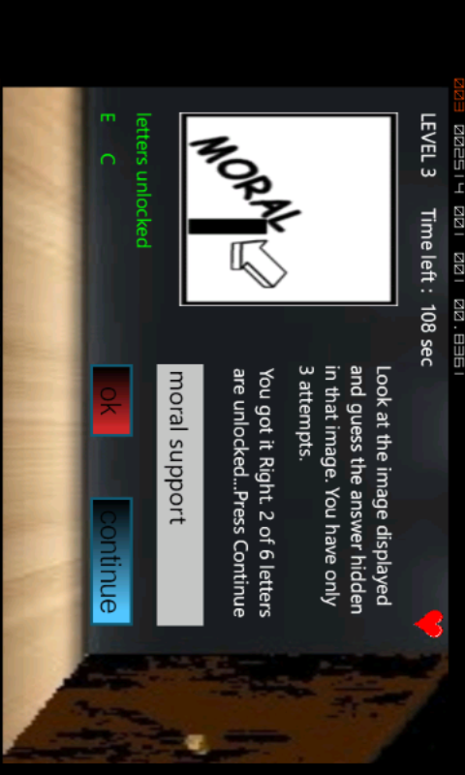

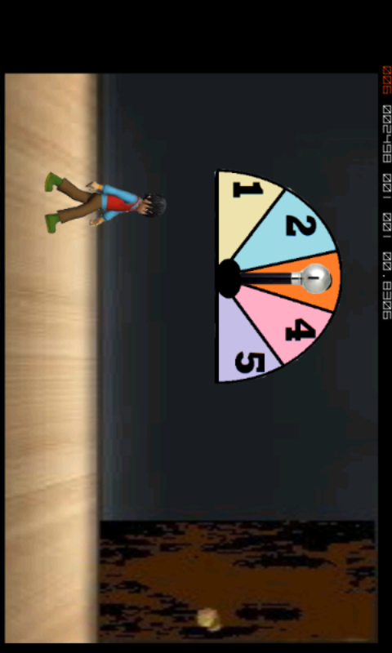

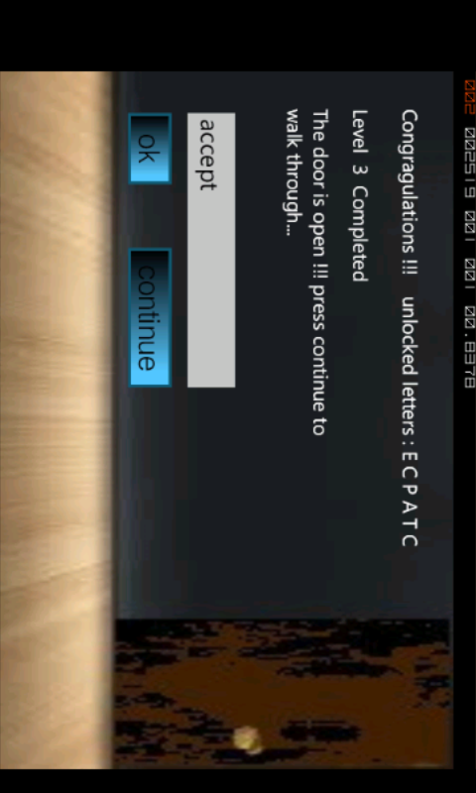

Level 4

Code:

using System;

using System.Collections.Generic;

using System.Linq;

using System.Net;

using System.Windows;

using System.Windows.Controls;

using System.Windows.Documents;

using System.Windows.Input;

using System.Windows.Media;

using System.Windows.Media.Animation;

using System.Windows.Shapes;

using Microsoft.Phone.Controls;

namespace MD

{

public partial class Page22 : PhoneApplicationPage

{

public Page22()

{

InitializeComponent();

System.Threading.Thread startupThread =

new System.Threading.Thread(new System.Threading.ThreadStart(timeDec));

startupThread.Start();

}

private void textBox1_TextChanged(object sender, RoutedEventArgs e)

{

}

Boolean flag1 = true;

Boolean flag4 = true;

void timeDec()

{

int k = 20, j = 1, m = 0;

for (int i3 = 0; i3 < 101; i3++)

{

System.Threading.Thread.Sleep(1000);

this.Dispatcher.BeginInvoke(() =>

{

if (flag1)

{

if (flag4)

{

string s1;

s1 = textBlock8.Text;

int num = int.Parse(s1);

num--;

s1 = num.ToString();

textBlock8.Text = s1;

//int q = int.Parse(s1);

if (i3 == 100)

{

flag1 = false;

}

}

else

{

}

}

else

{

// NavigationService.Navigate(new Uri("/Page36.xaml", UriKind.Relative));

}

});

}

// doStuff3();

}

int m = 2, i = 3;

Boolean flag = true;

Boolean flag2 = true;

Boolean flag3 = true;

private void button3_Click(object sender, RoutedEventArgs e)

{

if (flag)

{

string s1;

s1 = textBox1.Text;

if (s1 == "b")

{

flag4 = false;

textBlock10.Visibility = Visibility.Collapsed;

textBlock11.Visibility = Visibility.Collapsed;

button3.Content = "continue"; flag = false;

textBlock2.Text = "You got it Right. 2 of 7 letters are unlocked...Press Continue";

textBlock13.Text = "K";

textBlock14.Text = "O";

}

else

{

textBlock2.Text = "Sorry You are wrong !!!";

textBox1.Text = "";

if (m != 0)

{

if (m == 2)

{

textBlock2.Text = "Sorry You are wrong !!!";

textBlock11.Text = "2"; m--;

}

else if (m == 1)

{

textBlock2.Text = "Sorry You are wrong again !!!";

textBlock11.Text = "1"; m--;

}

}

else

{

if (flag2)

{

if (flag3)

{

image7.Visibility = Visibility.Collapsed;

textBlock2.Text = "You lost a life !!! ";

textBlock11.Text = "3";

m = 2;

flag3 = false;

}

else

{

image6.Visibility = Visibility.Collapsed;

textBlock2.Text = "You lost a second life !!! ";

textBlock11.Text = "3";

m = 2;

flag2 = false;

}

}

else

{

NavigationService.Navigate(new Uri("/Page35.xaml", UriKind.Relative));

}

}

}

}

else

{

NavigationService.Navigate(new Uri("/Page23.xaml", UriKind.Relative));

}

}

}

}

namespace MD

{

public partial class Page23 : PhoneApplicationPage

{

public Page23()

{

InitializeComponent();

System.Threading.Thread startupThread =

new System.Threading.Thread(new System.Threading.ThreadStart(timeDec));

startupThread.Start();

}

Boolean flag1 = true;

Boolean flag4 = true;

void timeDec()

{

int k = 20, j = 1, m = 0;

for (int i4 = 0; i4 < 101; i4++)

{

System.Threading.Thread.Sleep(1000);

this.Dispatcher.BeginInvoke(() =>

{

if (flag1)

{

if (flag4)

{

string s1;

s1 = textBlock8.Text;

int num = int.Parse(s1);

num--;

s1 = num.ToString();

textBlock8.Text = s1;

//int q = int.Parse(s1);

if (i4 == 100)

{

flag1 = false;

}

}

else

{

}

}

else

{

// NavigationService.Navigate(new Uri("/Page36.xaml", UriKind.Relative));

}

});

}

}

int m = 2, i = 3;

Boolean flag = true;

Boolean flag2 = true;

Boolean flag3 = true;

private void image1_ImageFailed(object sender, ExceptionRoutedEventArgs e)

{

}

private void button3_Click(object sender, RoutedEventArgs e)

{

if (flag)

{

string s1;

s1 = textBox1.Text;

if (s1 == "top")

{

textBlock4.Visibility = Visibility.Collapsed;

textBlock5.Visibility = Visibility.Collapsed;

button3.Content = "continue"; flag = false; flag4 = false;

textBlock6.Text = "You got it Right. 4 of 7 letters are unlocked...Press Continue";

textBlock11.Text = "T";

textBlock14.Text = "J";

}

else

{

textBlock6.Text = "Sorry You are wrong !!!";

textBox1.Text = "";

if (m != 0)

{

if (m == 2)

{

textBlock6.Text = "Sorry You are wrong !!!";

textBlock5.Text = "2"; m--;

}

else if (m == 1)

{

textBlock6.Text = "Sorry You are wrong again !!!";

textBlock5.Text = "1"; m--;

}

}

else

{

if (flag2)

{

if (flag3)

{

image2.Visibility = Visibility.Collapsed;

textBlock6.Text = "You lost a life !!! ";

textBlock5.Text = "3";

m = 2;

flag3 = false;

}

else

{

image7.Visibility = Visibility.Collapsed;

textBlock6.Text = "You lost a second life !!! ";

textBlock5.Text = "3";

m = 2;

flag2 = false;

}

}

else

{

NavigationService.Navigate(new Uri("/Page35.xaml", UriKind.Relative));

}

}

}

}

else

{

NavigationService.Navigate(new Uri("/Page24.xaml", UriKind.Relative));

}

}

}

}

namespace MD

{

public partial class Page24 : PhoneApplicationPage

{

public Page24()

{

InitializeComponent();

System.Threading.Thread startupThread =

new System.Threading.Thread(new System.Threading.ThreadStart(timeDec));

startupThread.Start();

}

Boolean flag1 = true;

void timeDec()

{

int k = 20, j = 1, m = 0;

for (int i5 = 0; i5 < 101; i5++)

{

System.Threading.Thread.Sleep(1000);

this.Dispatcher.BeginInvoke(() =>

{

if (flag1)

{

if (flag4)

{

string s1;

s1 = textBlock8.Text;

int num = int.Parse(s1);

num--;

s1 = num.ToString();

textBlock8.Text = s1;

//int q = int.Parse(s1);

if (i5 == 100)

{

flag1 = false;

}

}

else

{

}

}

else

{

// NavigationService.Navigate(new Uri("/Page36.xaml", UriKind.Relative));

}

});

}

// doStuff3();

}

private void image1_ImageFailed(object sender, ExceptionRoutedEventArgs e)

{

}

int m = 2, i = 3;

Boolean flag = true;

Boolean flag2 = true;

Boolean flag3 = true;

Boolean flag4 = true;

private void button3_Click(object sender, RoutedEventArgs e)

{

if (flag)

{

string s1;

s1 = textBox1.Text;

if (s1 == "96542")

{

textBlock4.Visibility = Visibility.Collapsed;

textBlock5.Visibility = Visibility.Collapsed;

button3.Content = "continue"; flag = false; flag4 = false;

textBlock2.Text = "You got it Right. All 7 letters are unlocked...Press Continue";

textBlock15.Text = "A";

textBlock16.Text = "P";

textBlock17.Text = "C";

}

else

{

textBlock6.Text = "Sorry You are wrong !!!";

textBox1.Text = "";

if (m != 0)

{

if (m == 2)

{

textBlock6.Text = "Sorry You are wrong !!!";

textBlock5.Text = "2"; m--;

}

else if (m == 1)

{

textBlock6.Text = "Sorry You are wrong again !!!";

textBlock5.Text = "1"; m--;

}

}

else

{

if (flag2)

{

if (flag3)

{

image2.Visibility = Visibility.Collapsed;

textBlock6.Text = "You lost a life !!! ";

textBlock5.Text = "3";

m = 2;

flag3 = false;

}

else

{

image7.Visibility = Visibility.Collapsed;

textBlock6.Text = "You lost a second life !!! ";

textBlock5.Text = "3";

m = 2;

flag2 = false;

}

}

else

{

NavigationService.Navigate(new Uri("/Page35.xaml", UriKind.Relative));

}

}

}

}

else

{

NavigationService.Navigate(new Uri("/Page25.xaml", UriKind.Relative));

}

}

}

}

Screen shots:

